**Test Strategy Document**

1. **Introduction**

The purpose of this document is to define the testing approach, objectives, and process to ensure the quality and functionality of the Demo Web Shop application.

1. **Test Objectives**

• Validate end-to-end user flows (e.g., product search, add to cart, checkout).

• Identify and fix UI/UX issues.

• Ensure security of user login and payment modules.

• Validate responsive design across browsers/devices.

1. **Test Scope**

• Functional testing (login, cart, checkout)

• UI testing

• Cross-browser testing

• Regression testing

• API testing

1. **Testing Types**

| **Test Type** | **Description** |
| --- | --- |
| Unit Testing | Done by developers |
| Functional Testing | verify business logic (e.g., cart works correctly) |
| Integration Testing | E.g., Cart + Checkout + Payment |
| Regression Testing | Ensure new builds don't break old functionality |
| Smoke Testing | Basic checks post-deployment |
| User Acceptance Testing (UAT) | Conducted by business users |

1. **Test Methodology**

• **Waterfall Model** (if using): Testing starts after development ends.

• **Agile Model** (preferred): Testing is done in iterations/sprints, integrated into the SDLC.

**. 6) Testing Environments**

| **Environment** | **Description** |
| --- | --- |
| Unit Dev | For initial dev testing |
| QA | Main test environment |
| Inte UT | E.g., Pre-production |
| Prod | Live site |

1. **Test Tools**

| **Environment** | **Description** |
| --- | --- |
| Unit Selenium | Automation |
| Postman | A API testing |
| JIRA | Bug /issue tracking |
| TestRail / Zephyr | Test case management |
| Browser Stack | Cross-browser testing |

1. **Technology Stack / Languages Used**

**🔹 Frontend:**

* **Languages**: HTML5, CSS3, JavaScript
* **Frameworks**: ASP.NET MVC, jQuery
* **UI Components**: Bootstrap

**🔹 Backend:**

* **Languages**: C#
* **Framework**: ASP.NET Core / .NET Framework
* **Authentication**: ASP.NET Identity (assumed for login modules)

**🔹 Database:**

* **DBMS**: SQL Server
* **Query Language**: T-SQL

**🔹 APIs (If any):**

* **Type**: REST (assumed)
* **Format**: JSON
* **Tools Used**: Postman for testing

**🔹 Automation (Proposed):**

* **Languages**: Java or Python (Selenium WebDriver)
* **Framework**: TestNG / PyTest / NUnit (if using C#)
* **CI/CD**: Azure DevOps / Jenkins (optional)

1. **Compatibility Testing**

* **Browsers**: Chrome, Firefox, Edge, Safari
* **Devices**: Desktop, Mobile, Tablet
* **OS**: Windows, macOS, Android, iOS

1. **Test Deliverables**

• Test Strategy Document

• Test Plan

• Test Case

1. **Risk and Mitigation**

| **Risk** | **Mitigation** |
| --- | --- |
| Changing requirements | Agile ceremonies for continuous feedback |
| Lack of test data | Use data generators or seed data scripts |
| Environment instability | Dedicated test environments with backups |

**Test Plans - Flowcharts & Diagrams**

**Flowchart 1: User Login Flow (Functional Test Case)**

|  |
| --- |
| Start  ↓  Open Homepage  ↓  Click Login  ↓  Enter Credentials  ↓  Click Submit  ↓  Validate Redirect to My Account  ↓  Success / Failure  ↓  End |

**Flowchart 2: Test Process Lifecycle (Waterfall)**

|  |
| --- |
| Requirement Analysis  ↓  Test Planning  ↓  Test Case Design  ↓  Test Execution  ↓  Direct Reporting  ↓  Retesting and Regression  ↓  Test Closure |

**Flowchart 3: Agile Sprint Testing Workflow**

|  |
| --- |
| Backlog Grooming  ↓  Sprint Planning  ↓  Test Case Design  ↓  Daily Stand-ups  ↓  Test Execution  ↓  Bug Fix and Retest  ↓  Sprint Demo  ↓ |
| Retrospective |

1. **Login page layout showing input fields and user options**

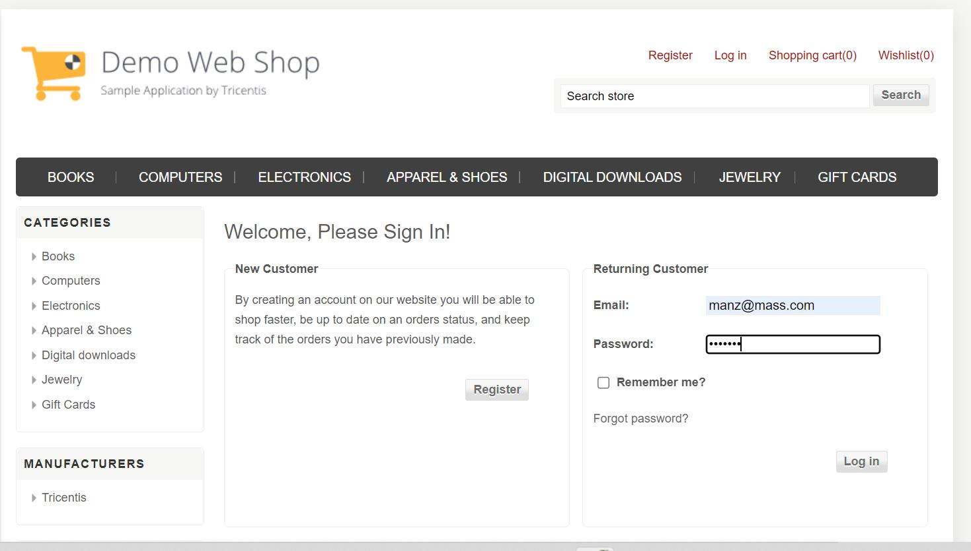

Figure 1: Demo Web Shop – Login Screen

1. **Entry & Exit Criteria**

**Entry Criteria**:

• Code is deployed to QA.

• Requirements/User Stories are frozen.

• Test cases are reviewed.

**Exit Criteria:**

• All critical defects resolved.

• Test case pass rate > 95%.

• UAT sign-off completed.

**14) Test Metrics**

| **Metric** | **Example** |
| --- | --- |
| Test Case Execution Rate | % of total test cases executed |
| Defect Density | Defects per module |
| Test Coverage | % of requirements covered |
| Defect Leakage | Defects found in UAT/Prod |

**15) Roles & Responsibilities**

| **Role** | **Responsibility** |
| --- | --- |
| QA Lead | Strategy, planning |
| QA Engineer | Write and execute tests |
| Automation Tester | Build/maintain automation |
| Product Owner | Approve UAT |
| Developer | Fix bugs |

**16) Defect Management**

• Tool: JIRA

• Priority: P0 to P3

• Status Workflow: New → Assigned → In Progress → Fixed → Retest → Closed

**17) Test Data Management**

• Dummy user accounts for login tests

• Product catalog data

• Payment simulations (sandbox mode)

**18) Test Schedule (Sample)**

| **Sprint** | **Features** | **Testing Period** |
| --- | --- | --- |
| Sprint 1 | Login, Register | Aug 1–Aug 5 |
| Sprint 2 | Cart, Wishlist | Aug 6–Aug 10 |
| Sprint 3 | Checkout, Orders | Aug 11–Aug 15 |